**Ascent User Guide**

* **Uploading Schedule**

Please follow the following steps to upload new schedule.

1. Logon to http://theinspirer.in/ascent/home.php#upload
2. Download format from the link
3. Make changes in the CSV File as per new schedule.
4. Rename the CSV File
5. Select the edited CSV File
6. Select region to which you want to make the schedule visible.
7. To verify Schedule Upload

Logon in Ascent android app with correct location and verify the uploaded schedule.

**Note :** Schedule in the android app will only be visible to specific locations as the schedule is uploaded.

Ex: If schedule is uploaded for Hydrabad region, the associate who have logged in with Hydrabad region will only be able to see the schedule uploaded for hydrabad.

If you have same schedule for different regions, You have to upload same schedule for different locations separately.

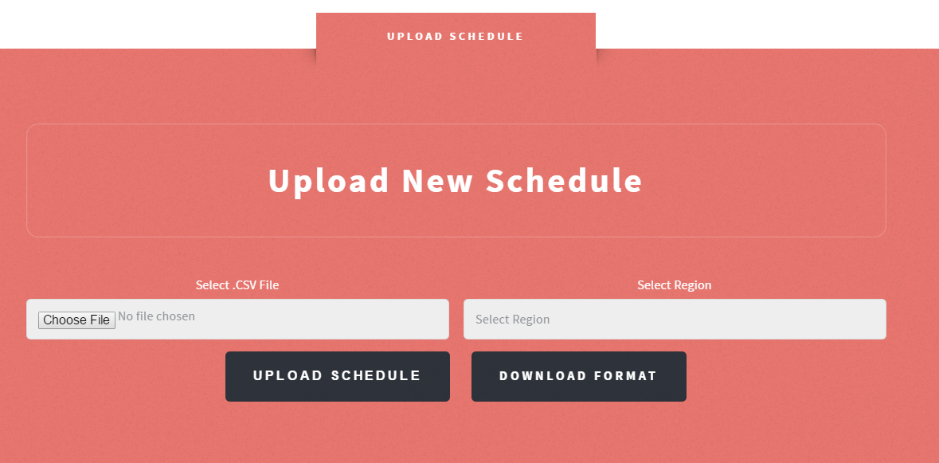

* **Editing Uploaded schedule details**

1. Visit : <http://theinspirer.in/ascent/home.php#edit>
2. Select date of which you want to edit schedule. All the sessions  
   for that day will be listed below, You can also delete particular session  
   using the delete icon adjacent to the details.
3. Below the details, You have to click "Select Activity to Edit",  
   It will list all the sessions of that day according to time of the session.
4. Select the specific session you want to edit.
5. The text fields will be populated to edit the session details.  
   Make changes and click Edit.
6. To verify Schedule Upload

Logon in Ascent android app with correct location and verify the uploaded schedule.

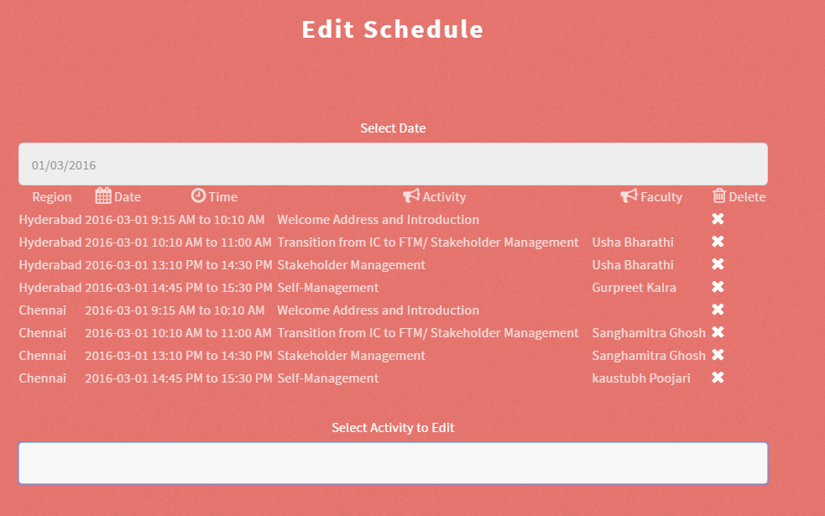

* **Downloading Feedback**

1. Visit : http://theinspirer.in/ascent/home.php#download
2. Select session date of which you want to download feedback
3. Select region of which you want to download feedback, or select "All" to download feedback for all regions for the specified date.
4. Select specific session or select "all" to download all feedbacks for all session for the specified region on that particular day.

